CATEGORY: COMMUNITY IMPACT

To submit your nomination, please follow these 4 easy steps:
1. Choose the appropriate award category for your nomination.
2. Complete the nomination package according to the guidelines.
3. Have the nominee sign the nomination package or forward and email indicating their consent and verification that the information submitted is accurate and complete. Subject line: PCIA Consent
4. Email the completed nomination form to events@pillarnonprofit.ca subject line: PCIA Nomination

The Impact Award is meant to recognize programs, initiatives, businesses or organizations whose work supports the nonprofit sector. An individual person will not be accepted for this category.

Nominee Information (Please complete in detail)

Nominee | Please submit the name of the program, nonprofit, charity, business, or government organization being nominated:
Name of Primary Contact representing the nomination
Email |  | Twitter Name
Street Address
City |  | Postal Code
Daytime Phone |  | Cellphone
Signature of Primary Contact or Representative

Nominator Information (Please complete in detail)

Name of Nominator
Relationship to Nominee
Email |  | Twitter Name
Street Address
City |  | Postal Code
Daytime Phone |  | Cellphone
Signature of Nominator

NOMINATION PACKAGE – COMMUNITY IMPACT AWARD

Please complete the package as outlined below. Please keep answers to the 500 word maximum.

COMMUNITY IMPACT AWARD APPLICATION

Nominees for this award have recognized new and more valuable ways to address a need in the community, despite the many demands and sometimes too few resources, faced by the nonprofit sector. Their efforts have had a positive and meaningful impact on the broader community, resulting in clear and measurable change. The nomination should use measures (that could include short-term and long-term outcomes) which demonstrates the change or improvement and determines the impact, that goes beyond meeting an immediate and identified need. The nominee’s impact extends to provide opportunities to enhance the lives of individuals, meet additional needs and build a sense of community.

1. Please describe the significant impact on the community recognized by the nominee’s efforts.
(500 words.)

2. Demonstrate the additional ways the nominee’s impact provides benefit to the broader community. (500 words.)

3. Please demonstrate the apparent and measurable change or improvement in the community that resulted from the nominee’s efforts. (500 words.)

4. How did the nominee encourage diversity and inclusiveness in the community?
(500 words.)

5. How can others learn from this nominee’s example of community impact?

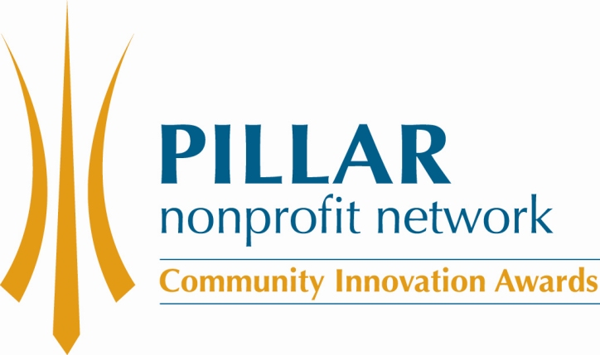
(500 words.)

